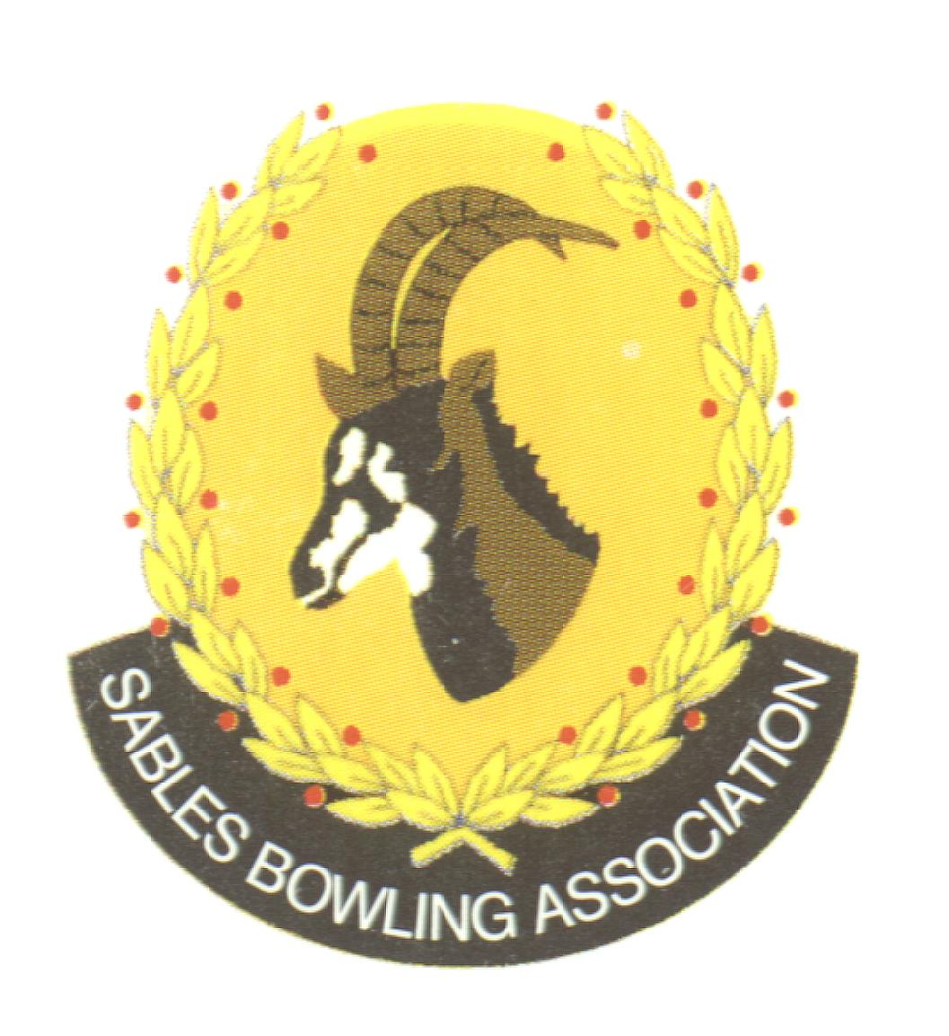
Club Memo 68/2022-2023
Memorandum
From
SABLES BOWLING ASSOCIATION
13th October 2023

TO: CLUBS PRESIDENTS

TO: CLUBS SECRETARIES

SUBJECT: Sables Vice-President and Competitions Secretary Positions 2023
---------------------------------------------------------------------------
Dear All

We herewith have great pleasure advising that the positions of Vice-President and Competitions Secretary on the Sables Executive Committee has been filled by the following persons:

Elysses Heine (Krugersdorp BC) as Vice-President
Paul Thompson (Maraisburg BC) as Competitions Secretary

We the Executive wish them everything of the best with the way forward.

Kind Regards
Mark Petzer
Sables District President

Cell No: 071 688 3088
E-MAIL: sablesbowls@gmail.com

