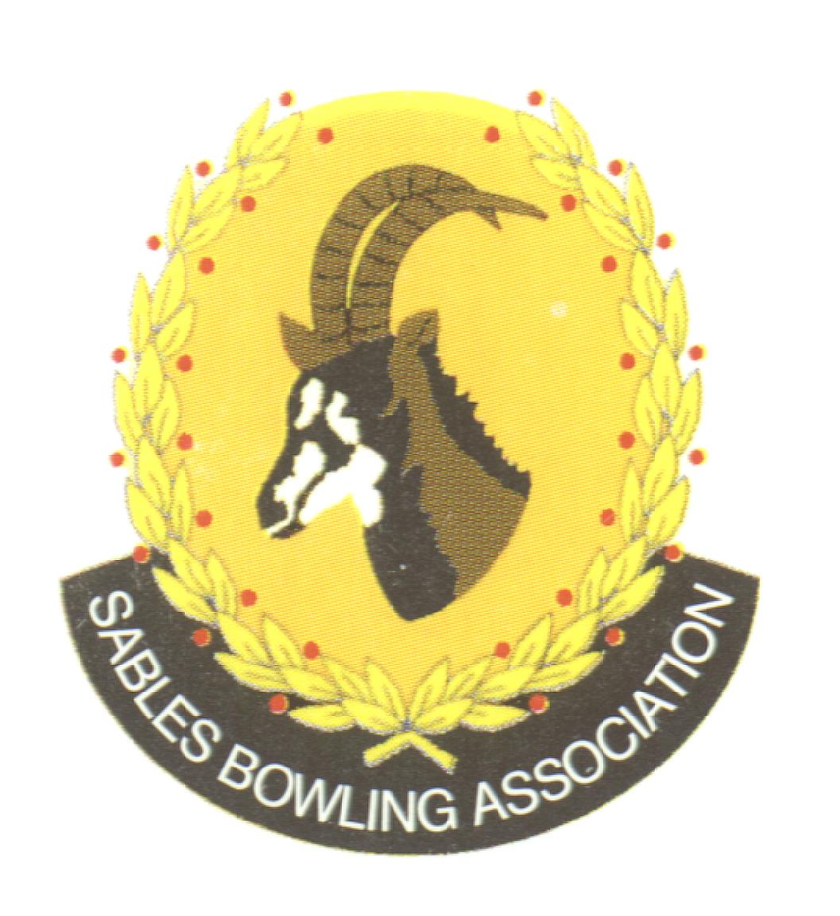
Club Memo 67/2022-2023
Memorandum
From
SABLES BOWLING ASSOCIATION
2nd October 2023

TO: CLUBS PRESIDENTS

TO: CLUBS SECRETARIES

SUBJECT: Club Coaches Information 2023
---------------------------------------------------------------------------
Dear All

The DSCC would like to involve more of our qualified coaches in planned coaching in Sables.
It is a matter of concern that there may not be adequate coaching facilities at some clubs and that some coaches are unaware of the changes that are taking place in the skills development arena.
The areas that we would wish to see considered are:
- Making coaching available at all clubs with set days and times.
- Increasing the attendance at the Academy and holding sessions at different clubs.
- Involving more coaches with the various sable’s district squads.
- Increasing the level of skills of coaches without the need for attending the more formal coaches’ courses.
- Reset the DSCC to increase its effectiveness.
- There may be other areas that require consideration…we are open to input from any source.
We propose a morning meeting for all coaches who might be interested to take place on the

22nd of October at Krugersdorp Bowls Club.

To have any hope of achieving our objectives we need the support of clubs in general, not just the coaches.

Attached is a list of those coaches who are listed as currently qualified on the BSA website.
We are not confident that this list is as accurate as we would hope and need the club’s assistance in ensuring that:

We have a correct list…we have not missed anyone.
They are in fact based at the clubs that we think.
We have the correct contact details.

We ask, please.

Will clubs check the list, insert the contact details, and send them to the DSCC.
(If there are errors, please advise us)
E-mail us.
dragonsholme@absamail.co.za
Will the clubs please advise the coaches of the meeting and encourage them to attend.

Kind Regards
Mark Petzer
Sables District President

Cell No: 071 688 3088
E-MAIL: sablesbowls@gmail.com

