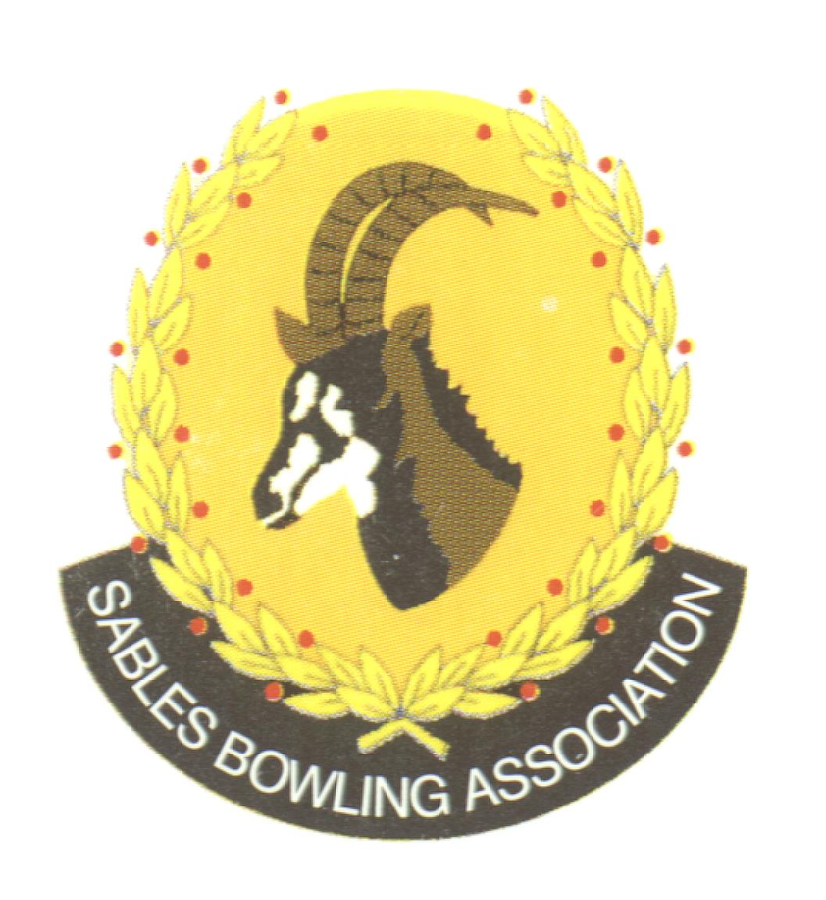
Club Memo 66/2022-2023
Memorandum
From
SABLES BOWLING ASSOCIATION
26th September 2023

TO: CLUBS PRESIDENTS

TO: CLUBS SECRETARIES

SUBJECT: Applications for the position of District Competitions Secretary
---------------------------------------------------------------------------
Dear All

The Sables Executive herewith invite applications for the portfolio of the Sables District Competitions Secretary. Please submit your application accompanied by your CV to the District Office. The closing date for applications is the 10th October 2023.

Kind Regards
Mark Petzer
Sables District President

Cell No: 071 688 3088
E-MAIL: sablesbowls@gmail.com

