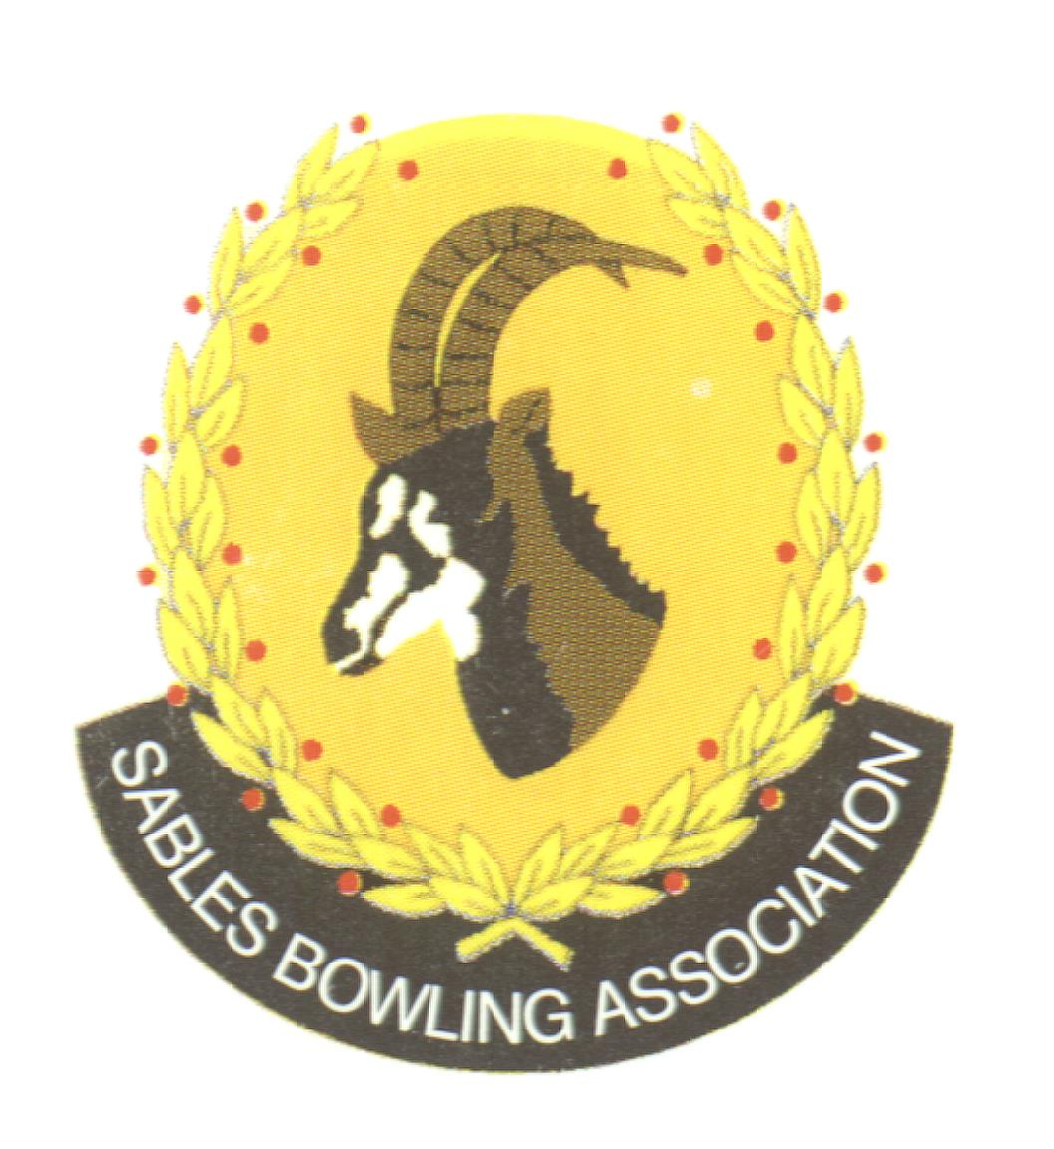
Club Memo 65/2022-2023
Memorandum
From
SABLES BOWLING ASSOCIATION
20th September 2023

TO: CLUBS PRESIDENTS

TO: CLUBS SECRETARIES

SUBJECT: Executive Committee Members resignations 2023
---------------------------------------------------------------------------
Dear All

The Sables Executive wish to inform you of the resignation of the following Executive Members

Jan Bester Vice-President
Janet Blythe Sables Competitions Secretary

Please may we request that you send any correspondence to the District Office.

Kind Regards
Mark Petzer
Sables District President

Cell No: 071 688 3088
E-MAIL: sablesbowls@gmail.com

